

***Front-end Essentials***

**Training Assignment**

|  |  |
| --- | --- |
| Document Code | 25e-BM/HR/HDCV/FSOFT |
| Version | 1.1 |
| Effective Date | 7/1/2019 |

RECORD OF CHANGES

|  |  |  |  |  |  |
| --- | --- | --- | --- | --- | --- |
| No | Effective Date | Change Description | Reason | Reviewer | Approver |
| 1 | 30/May/2019 | Create a new assignment | Create new | DieuNT1 | VinhNV |
| 2 | 07/Jun/2019 | Update Fsoft Template | Update | DieuNT1 | VinhNV |
|  |  |  |  |  |  |
|  |  |  |  |  |  |
|  |  |  |  |  |  |
|  |  |  |  |  |  |
|  |  |  |  |  |  |
|  |  |  |  |  |  |
|  |  |  |  |  |  |
|  |  |  |  |  |  |

Contents

Unit 11-12: DOM and Events 4

Objectives 4

Specification: 4

Bonus: 6

|  |  |
| --- | --- |
|  | **CODE: JS-E.M.A1202 (Quiz App)**  **TYPE: Medium**  **LOC: 300**  **DURATION: 180 minutes** |

# Unit 11-12: DOM and Events

Objectives

* Understand DOM and how to use DOM Events to interact with web page
* Understand Model-driven concept with working with DOM

Specification:

You have to design an Online Quiz using OOP style. The app consists of 3 mains parts (see below figure)

1. The title: **JavaScript Online Quiz**
2. The Question Container which contains the Question and a list of choice. User can only choose 1 answer from the list.
3. Button Group: Previous Question, Next Question, Submit

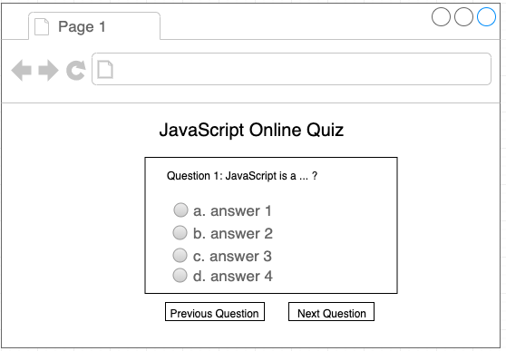

Suppose we have 20 Questions in total.

If the current question is 1 (count from 1 to 20), only **Next Question** button is shown. Click on this button will show next question (in this case question number 2).

If current question is from 2 to 20, then **Previous Question** must be show. Click on that button will show previous question.  
If you are at last question (Question number 20), you must show **Submit Quiz** button, and hide Next Question (there is no more next question). If user click on this button, you must show his/her total score below the Button Group

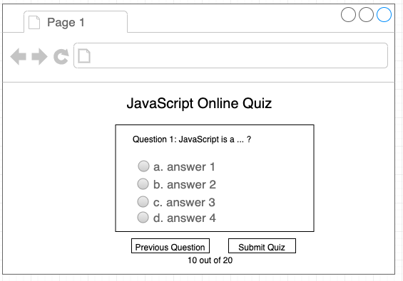

Find below the list of questions represented in JavaScript:

1. const myQuestions = [
2. {
3. question: 'Javascript is _________ language.',
4. answers: {
5. a: 'Programming',
6. b: 'Application',
7. c: 'None of These',
8. d: 'Scripting'
9. },
10. multi: false,
11. correctAnswer: 'd'
12. },
13. {
14. question:
15. 'Which of the following is a valid type of function javascript supports?',
16. answers: {
17. a: 'named function',
18. b: 'anonymous function',
19. c: 'both of the above',
20. d: 'none of the above'
21. },
22. multi: false,
23. correctAnswer: 'c'
24. },
25. {
26. question:
27. 'Which built-in method returns the index within the calling String object of the first occurrence of the specified value?',
28. answers: {
29. a: 'getIndex()',
30. b: 'location()',
31. c: 'indexOf()',
32. d: 'getLocation()'
33. },
34. multi: false,
35. correctAnswer: 'c'
36. },
37. {
38. question: 'Which one of the following is valid data type of JavaScript',
39. answers: {
40. a: 'number',
41. b: 'void',
42. c: 'boolean',
43. d: 'nothing'
44. },
45. multi: false,
46. correctAnswer: 'c'
47. }
48. ];

Bonus:

Extend the functionality of the app to support Question with Multi Choice without breaking the current flow.